Validation Experiment of RAAIM

Dataset: c-d-r-AN_FPL_2013_06_04__14_09_08.tif Output
- Parameter List_edit.txt
- rgb.png
- ROI normalized.txt

I. Normal Data (not randomized)

A. Tables

(a) Visualization of the Data:

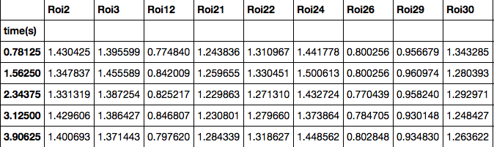
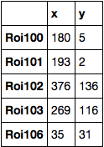

[Top rows of the dataset] [ROI location]

(b) Cross Correlation Matrix (Friends)
r = 0.8
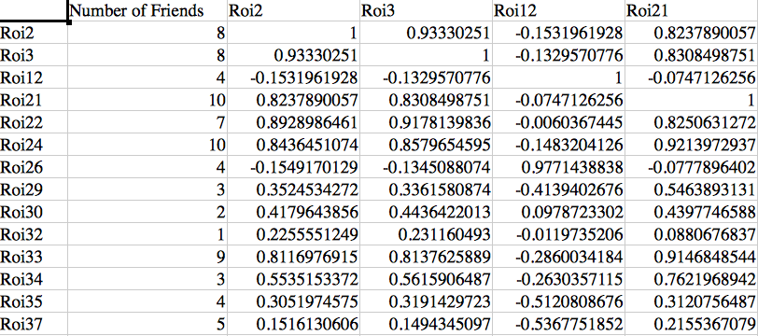

[xcor.csv]

(c) Distance Matrix (neighbors)
d = 50
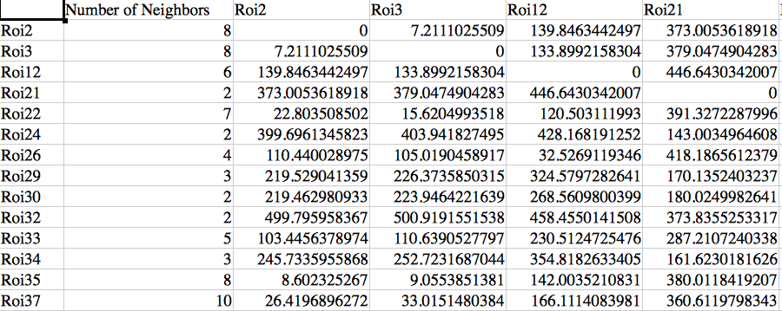

(d) Friends in terms of neighbors

Distance Sum: the sum of the distances from each roi to its friends
Friend Number: the number of friends that each roi has (not including itself)
Rel Dist: The cummulative distance / number of friends

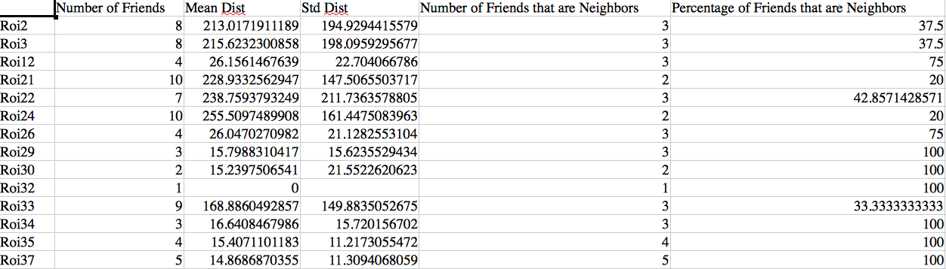
[friend distances.csv]

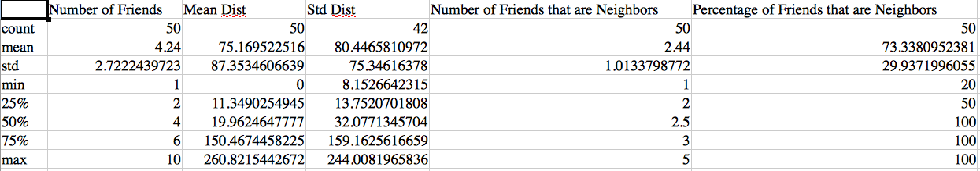
[friend distance summary.csv]

(e) neighbor in terms of friends

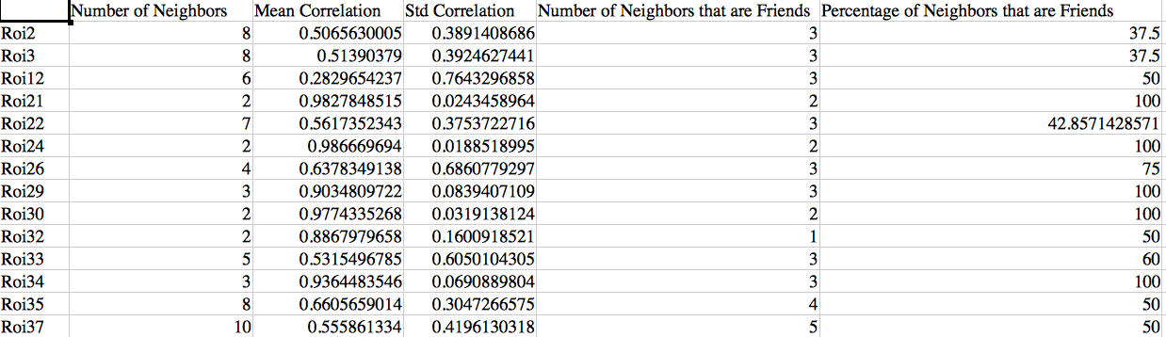
[neighbor correlation]

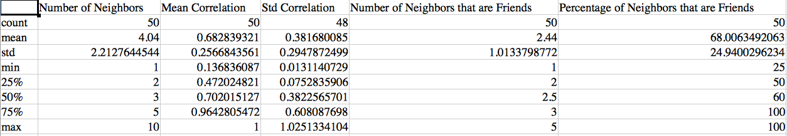
[neighbor correlation summary]

B. Plots

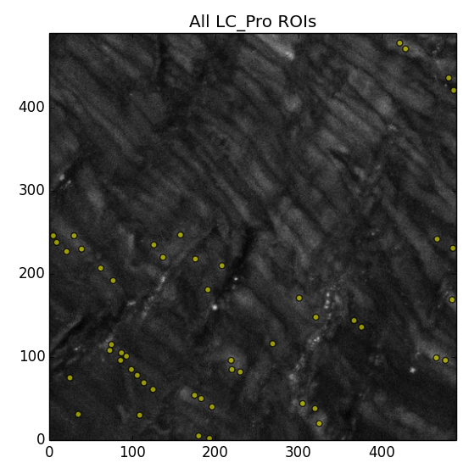
(a) 2D plots

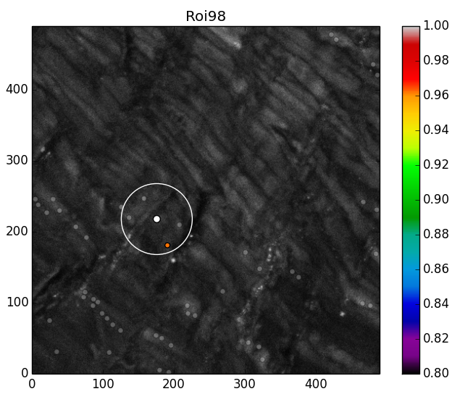

(b) Line Plots

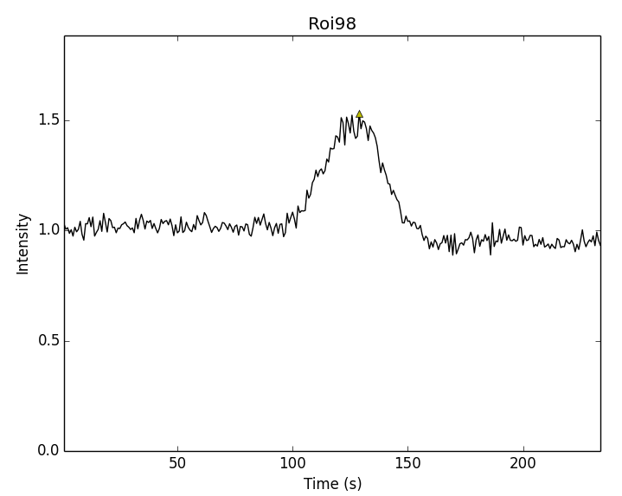

[individual line plot of Roi98 – triangle represent an event]

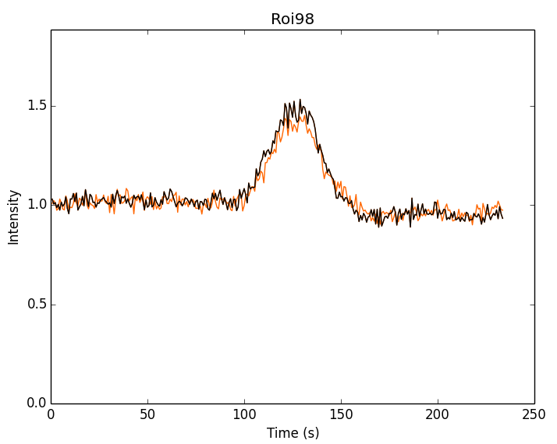

[Stacked line plot – black is the Roi98 and orange is the friend]

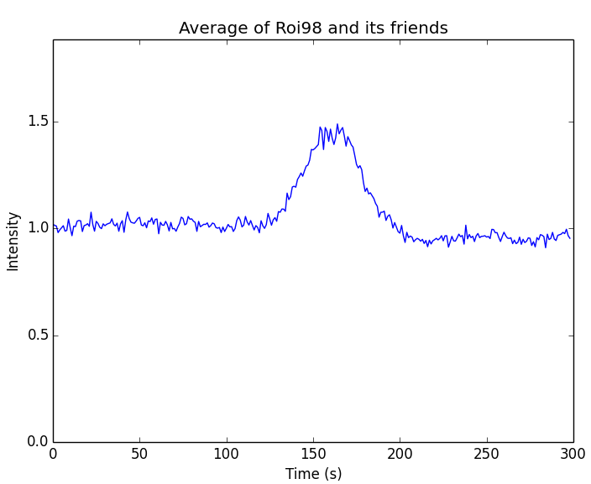

[Average of Roi98 and its friends]
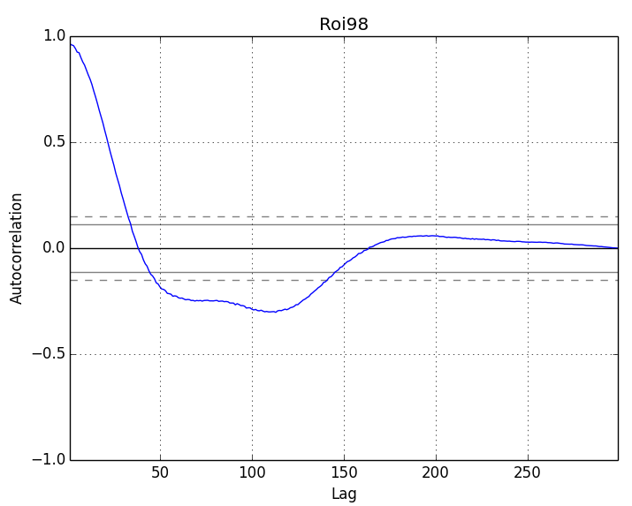

[autocorrelation plot of Roi98]

II. Random Data (randomized)

A. Tables

(a) Visualization of the Data:

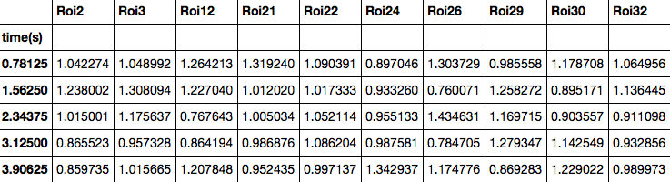

[top rows of the dataset] [ROI location]

(b) Cross Correlation Matrix (Friends)
r = 0.8
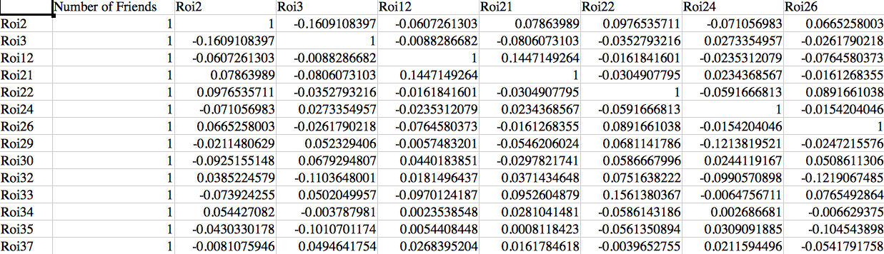
[xcor_random.csv]

(c) Distance Matrix (neighbors)
d = 50

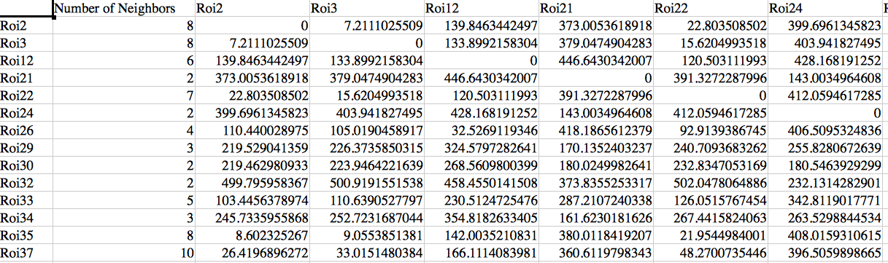
[dist_matrix_random.csv]

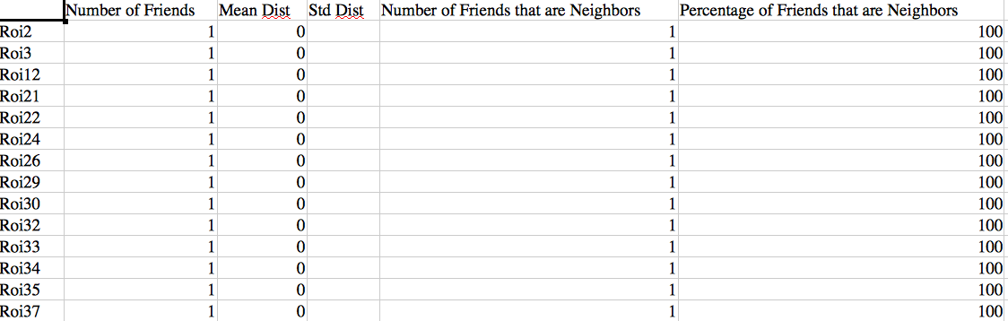
(d) friends in terms of neighbors

[friend_distances_random.csv]

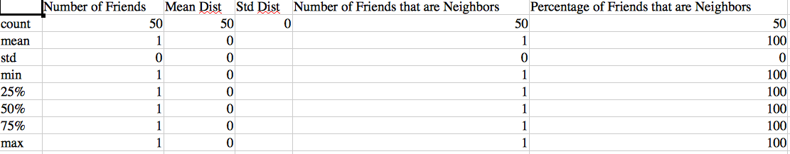
[friend_distances_summary_random.csv]

(e) neighbors in terms of friends
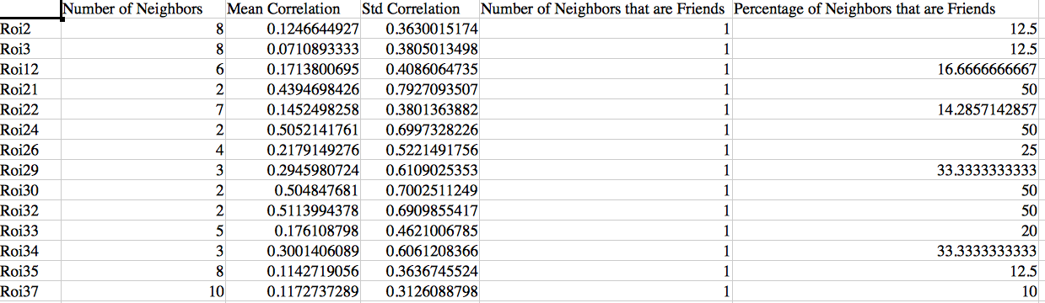
[neighbor_correlation_random.csv]

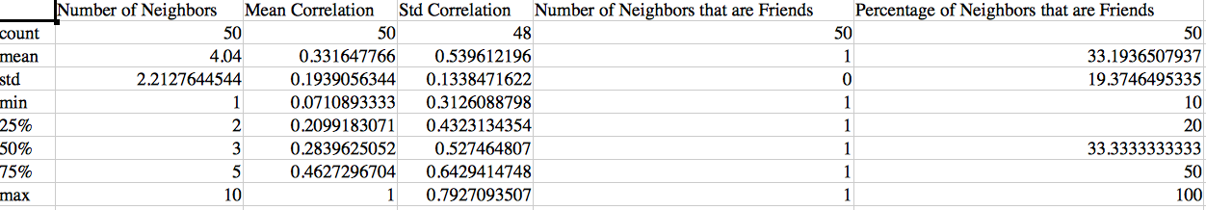
[neighbor_correlation_summary_random.csv]

B. Plots
(a) 2D plots

[2D plot with all ROIs]

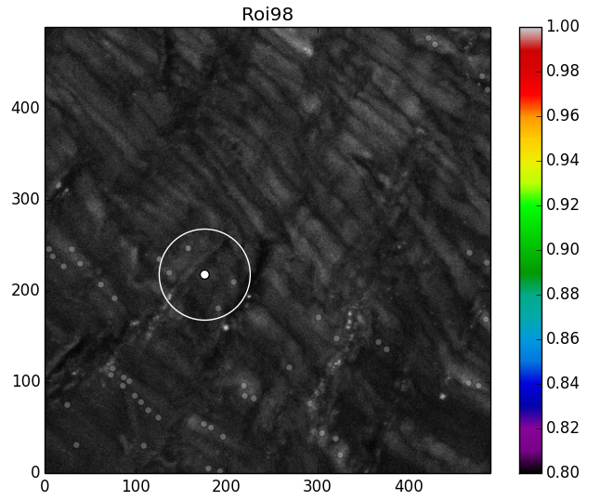

[2D plot with Roi98 and friends]

(b) Line plots
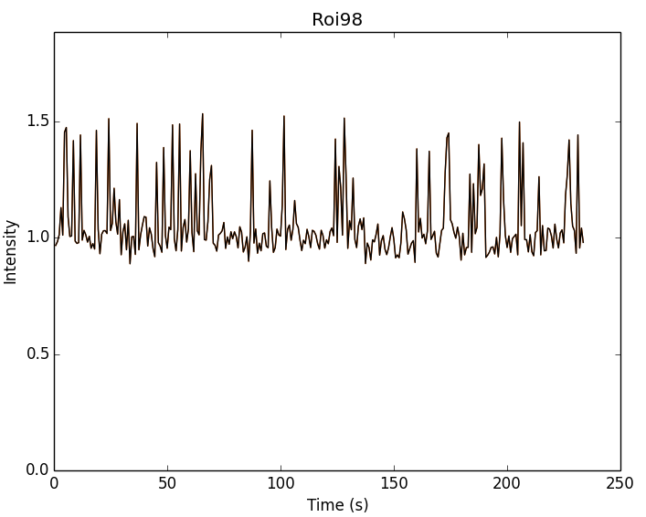

[Roi98 and friends stacked line plot]

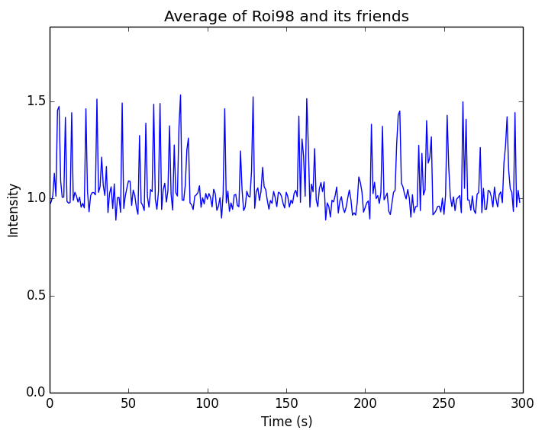

[Average of Roi98 and its friends]

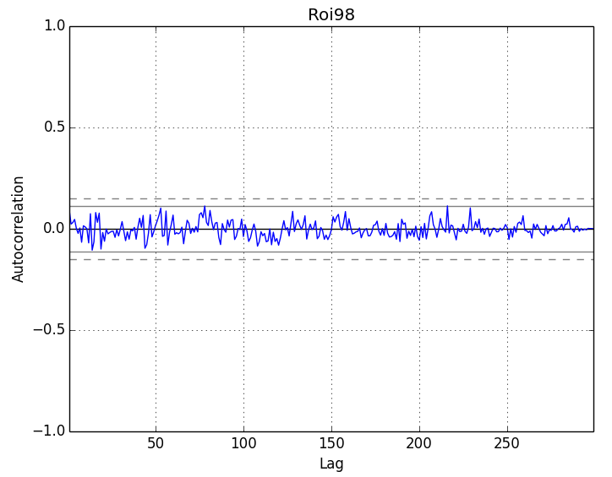

[autocorrelation plot of Roi98]

